Slovak Open Science Forum – 28.11.2023

The conference will be held under the auspices of the Ministry of Education, Science, Research and Sport of the Slovak Republic.

We are looking forward to meeting you at the Slovak Open Science Forum on November 28, 2023. Registration will be open soon.
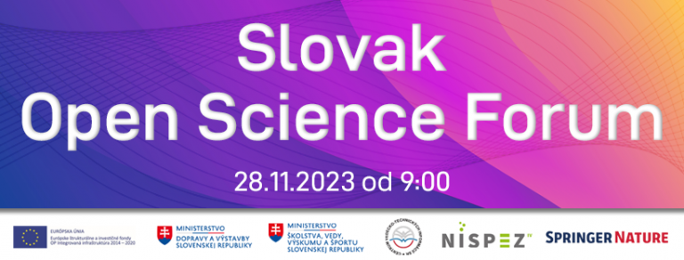
Programme
08:00-09:00 Registration
09:00-09:15 Opening of the Conference – Welcome
09:15-10:45 Session 1 (Open Access Publishing, Transformative Agreements, Diamond OA Publishing)
10:45-11:00 Coffee Break
11:00-11:30 Panel discussion (Research Assessment Reform)
11:30-12:00 TBA
12:00-13:00 Lunch
13:00-14:00 Session 2 (Open Science Education)
14:00-15:00 Session 3 (Copyright)
15:00-15:30 Closing session
Meet our speakers
Please click here for more information about our speakers. https://otvorenaveda.cvtisr.sk/speakers-bios/

Venue
Slovak Open Science Forum will be held in the Pálffy Palace on 47 Zámocká Street (Bratislava, Slovakia). Pálffy Palace is a national cultural monument from the middle of the 17th century.
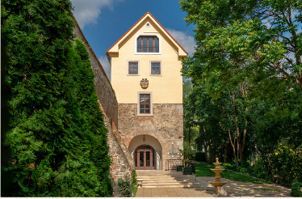
The conference will be held in English.

Link to the Google maps. Pálfiho palác – Mapy Google

Source: 28.11.2023 Slovak Open Science Forum - Otvorenaveda (cvtisr.sk)

